

**CAPSTONE PROJECT A and B**

**Interim Report**

**BRIGHT ELECTRICALS**

***SUBMITTED TO-:******SUBMITTED BY-:***

MR.SYED ALTAF PRANAV SHARMA K170862

DILAWER SINGH K161707

SIMRANJEET SINGH K170026

SHARANDEEP KAUR K170102

# 

***TABLE OF CONTENTS***

Contents

Project Summary 3

Project Purpose 3

Scope of the project 3

Project Objective 3

Project Assumptions 3

Project Constraints 4

Key Deliverables 4

Project Budget 5

Project Organisation 5

Gant chart -: 6

Work Breakdown Structure 7

Risk management 7

References 7

# Project Summary

The aim of the project is to design an online system for Electrical business. The platform is designed in a way that it will allow customers to view the objects and customers will be able to buy the products using different payment methods and also allows customers to request for installation of the electrical products. The system will focus on the selling of the products as well as providing installation services to the clients. The project will also promote the business as allowing clients to Sign up their existing accounts and could get avail exciting offers.

# Project Purpose

The purpose of the project is to provide Electrical services to the clients at reasonable price and the business will allow clients to get installation services. The business will provide facility to pay online via Debit or Credit Card.

The purpose of this project is to provide customers with hassle free shopping and also allows new customer to sign In in a secure way using proper security encryption concerns.

# Scope of the project

The scope of the project will be that it provides web based system and not any mobile application.

The project will offer customers to buy products online and will provide a shopping cart and

The project will offer clients to heads up for credit card payment option.

It will allow clients to select for installation service and also can check whether they are eligible for further discounts.

# Project Objective

* Developing a online platform for the Electrical sealing Brand.
* Joining the different categories of Electric purchasers in the broader geographical region.
* Managing accounts of different groups of users such as admin, new customer, and already existing customer etc.

# Project Assumptions

* It is assumed that project hosting the server have the capacity to run PHP and MYSQL database server.
* The hosting project will give an interface for the online transactions and will allow customers to pay via card system.

# Project Constraints

* This project can take long time to develop as it is a time bounded plan so there is a need to preserve time constraints.
* The lack of resource can be other constraints as there are limited resources.
* Limited number of programmers is available for doing this task so efficient use of resources is highly required.

# Key Deliverables

* **Functional Requirements and Non-Functional requirements**

|  |  |
| --- | --- |
| Functional Requirements | Non-Functional Requirements |
| The website must have Home page that list all the latest releases and information regarding new products available in company. | Performance: - This is all about the response time, utilization, throughput, static volumetric. |
| Join/Login: - Customers can create an account and save their details when they visit website next time they can just sign in and speed up their shopping. | Control and Security: - The system must secure from all external cyber threats those can make damage to website. |
| Shopping cart: - In header we’ll add shopping cart where customer can add products to their cart, and they can see that cart option on all pages. | Efficiency: - This requirement represents the ability of system to produce the output. |
| Contact: - Contact us page will be there where shoppers can contact support via email and call. | Availability: - The system will work 24*7 |
| Enquiry Form: - Users can fill enquiry form if they have any queries related to product. | Scalability: - The system which able to handle a wide variety of system configuration size. |
| About Product: - Every product will have their picture and cost written to their bottom. | Usability: - The system will be friendly so the user can feel comfort while surfing website. |
| Search bar: - Homepage will have search bar where customer can search for different product throughout website. | Adaptability: - to problems and another environment. |
| The Website will be responsive as user can use it on any device. | Maintainability: - repairs, any changes to functionalities. | |
| If any user forgot their username or password, then they can reset their details by sending request to helpdesk. | Testability: - reporting of error and testing of system. | |
| On every page in footer option there will be social media links where customers can connect organization through social media to get updates about products. |  | |
| There will be different options to pay for products such as debit card, after pay. |  | |
| Customers can have access to super special products by clicking on link of super special deal. |  | |

# Project Budget

* There is not any associated cost of this project but here we have got some estimation cost based on current prices that linked with our project.

|  |  |  |  |  |
| --- | --- | --- | --- | --- |
| Cost |  | | Totals | |
| Direct Costs | **Labor** | |  | |
|  | Writer | | $2000 | |
|  | Research | | $250 | |
|  | Layout | | $1100 | |
|  | Design | | $1,500 | |
|  | Total Direct Labor | | $4850 | |
| Total Direct Cost |  | | $4910 | |
| Administration Costs | |  | | $912 |
| Overall Project Total | |  | | $5822 |

# Project Organisation

* Project’s Owners Organization: **Bright Electrical**
  + Web based platform for buying various types of Electrical appliances.
  + Advanced services for the customers.

# Gant chart -:

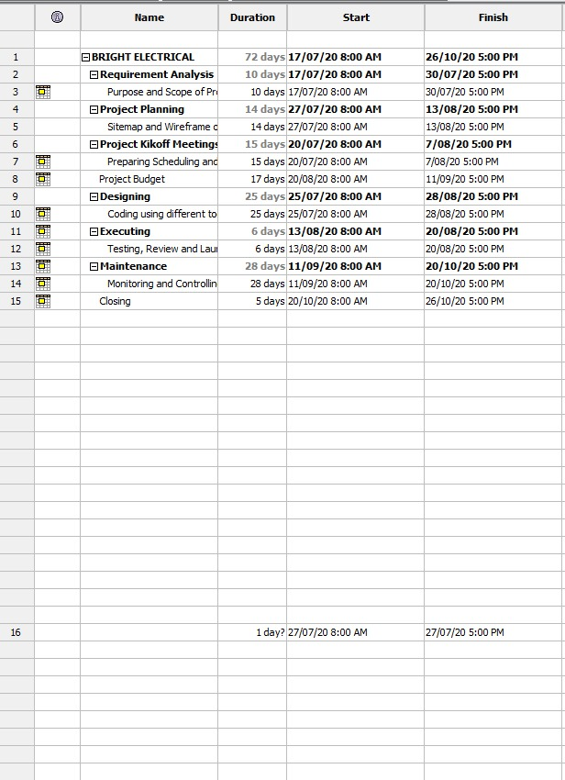

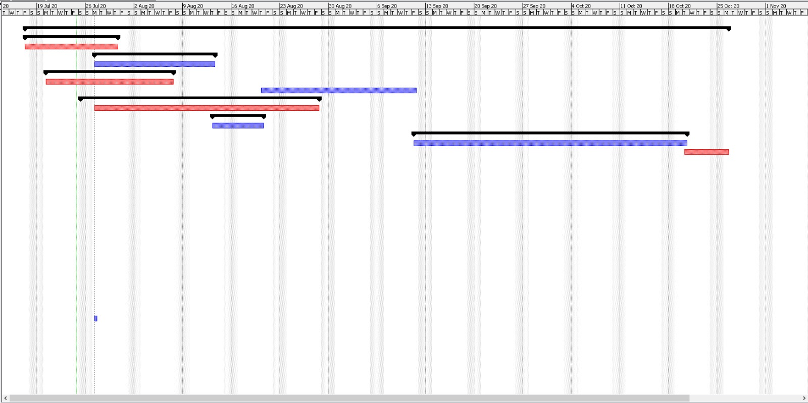

# 

# Work Breakdown Structure

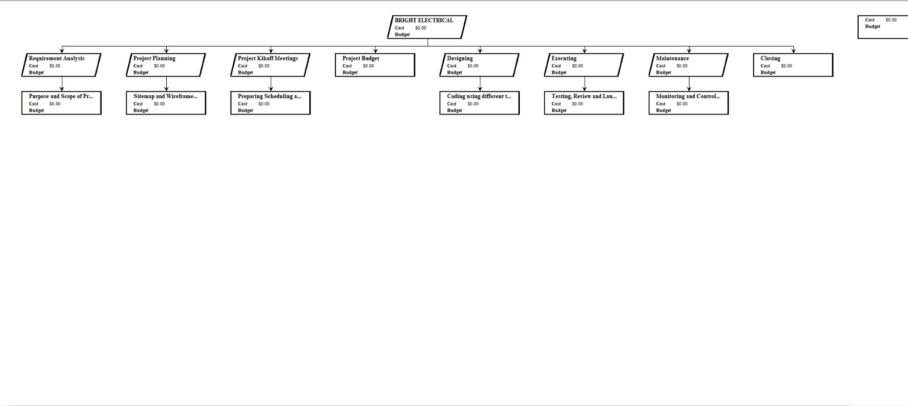

# Risk management

Risk management is important part of project as we have to predict the possible risks to the project and how could we reduce its impact on the working of the project. Risk management is essential for the smooth functioning of the system. Some of the possible risks and mitigation plan is as follow-:

|  |  |
| --- | --- |
| RISKS | MITIGATION PLAN |
| On time completion of tasks | Monitoring of the project, Conducting meetings with the group members within specific interval. |
| Not knowledgeable about the Requirements needed. | More communication with the clients and with team members.  Giving focus on requirement analysis phase. |